ASSIGNMENT NO. 11: Indexing and Query Optimization Queries

Questions
Q1) Create a MySQL database named SalesDB and a table named OrderData.
OrderData Table
Column Name | Data Type | Constraint
OrderID | INT | PRIMARY KEY
CustomerName | VARCHAR(50) | NOT NULL
Email | VARCHAR(80) | NOT NULL
City | VARCHAR(30) | NOT NULL
ProductCategory | VARCHAR(30) | NOT NULL
OrderDate | DATE | NOT NULL
OrderAmount | DECIMAL(10,2) | NOT NULL
OrderStatus | VARCHAR(20) | NOT NULL
Insert at least 12 records into the table.

QUERY:
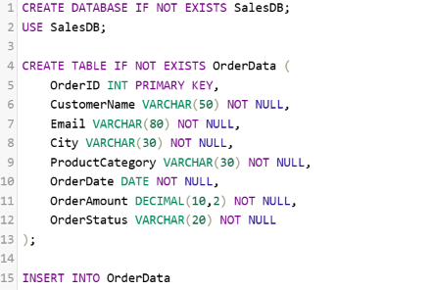
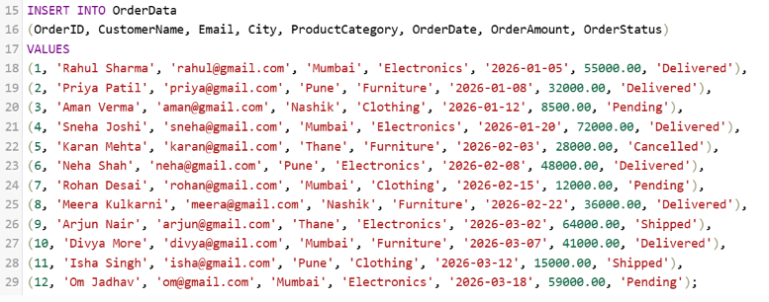
OUTPUT:
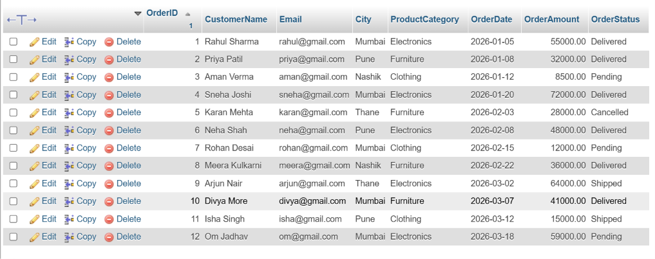

Q2) Create the following MySQL indexes on the OrderData table:
Index Name | Column | Index Type
idx_city | City | Normal index
idx_email | Email | Unique index
idx_order_date | OrderDate | Normal index

QUERY:
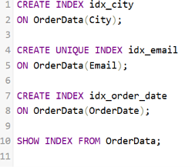

OUTPUT:
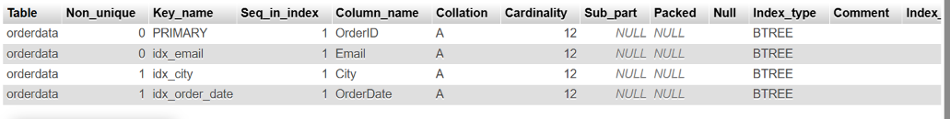

Q3) Create a composite index named idx_city_order_date.
The index should contain:
Index Position | Column
1 | City
2 | OrderDate

QUERY:
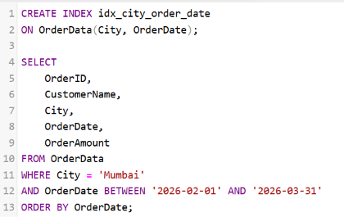

OUTPUT:
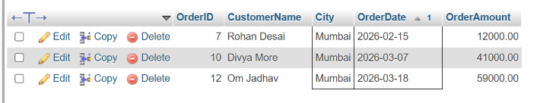

Q4) Write a MySQL EXPLAIN query to analyze the following search:
SELECT *
FROM OrderData
WHERE City = 'Mumbai';
Record and explain the following output columns:
EXPLAIN Column
type
possible_keys
key
rows
Extra

QUERY:
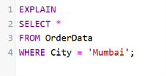

OUTPUT:

Q5) Compare query performance before and after creating an index on City.
Perform the following steps:
Step | Task
1 | Drop idx_city, if it exists
2 | Run EXPLAIN on the City search
3 | Create idx_city
4 | Run the same EXPLAIN query again
5 | Compare the selected index and estimated rows

QUERY:
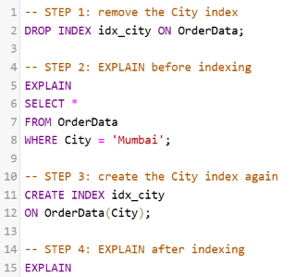
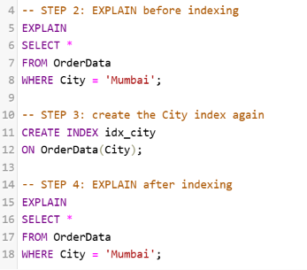

OUTPUT:
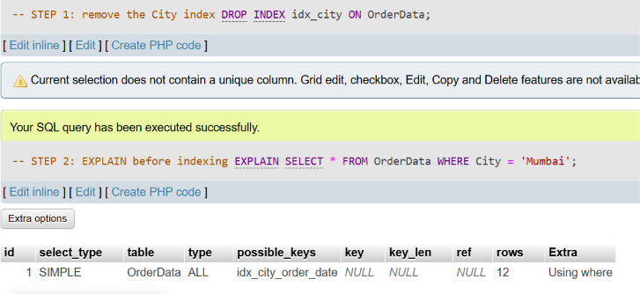
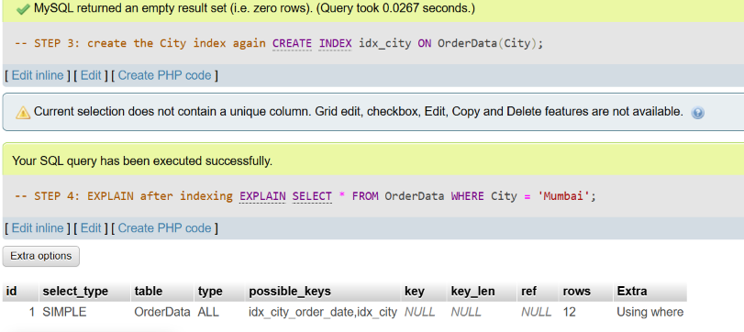

Q6) Rewrite the following query in a more index-friendly form:
SELECT *
FROM OrderData
WHERE YEAR(OrderDate) = 2026;
The improved query should:
Requirement
Avoid applying a function to OrderDate
Use a start date
Use an end date
Select only OrderID, CustomerName, OrderDate, and OrderAmount
Be analyzed using EXPLAIN

QUERY:
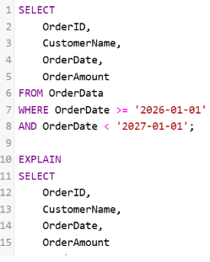
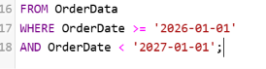

OUTPUT:
